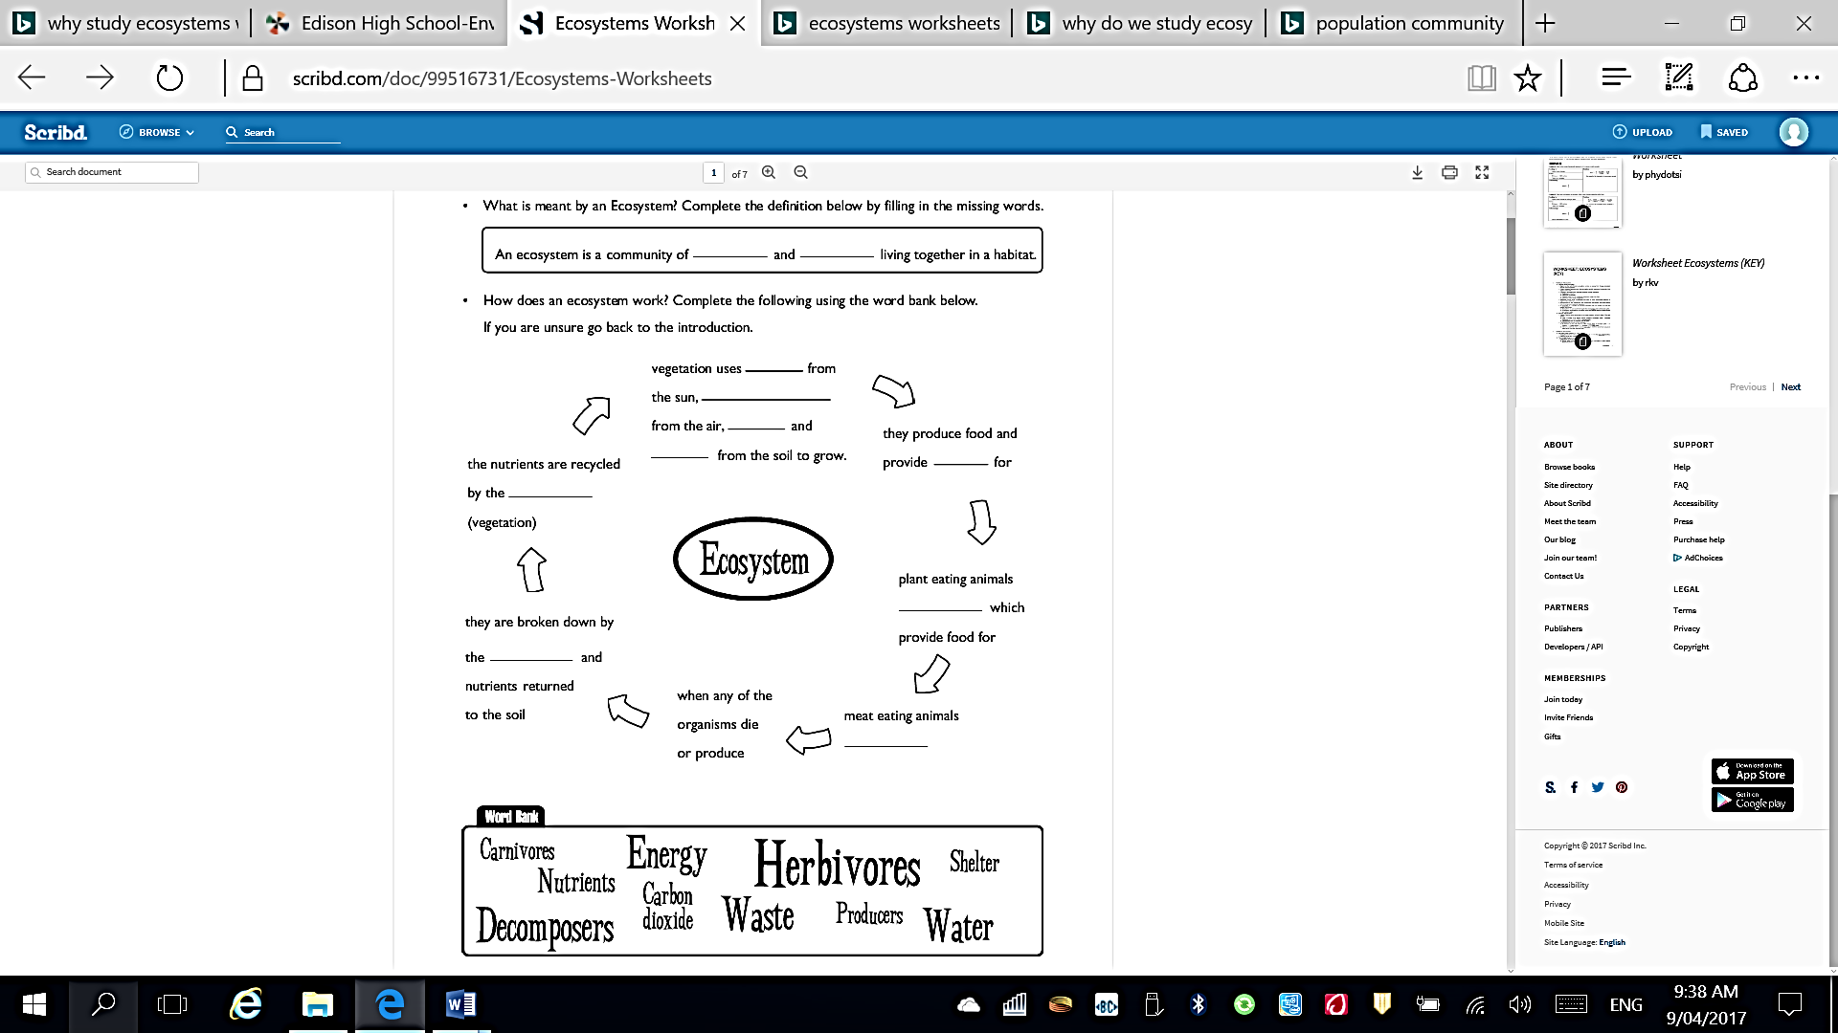**Introduction to Ecosystems**

**carnivores**

**carbon dioxide**

**waste**

**shelter**

**nutrients**

**herbivores**

**energy**

**decomposers**

**water**

**producers**

**consumers**